**Exercise 1: Change servo motor resolution (step size)**

The shaft position is mapped from 0-180 degree to variable angle range 0-1 values. What is the angle (degree) represented by angle step size 0.05 ?

Modify the code as

angle = 0:0.05:1

Attach the screenshot of motor position sequence.

Answer: The resolution angle is 180*0.05 = 9 degree represented by step size 0.05.

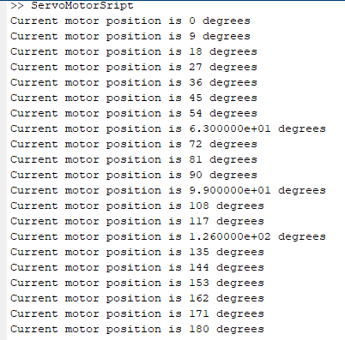

**Exercise 2: generating a repeated sequence stairs**

The servo write block takes values ranging from 0 to 180.

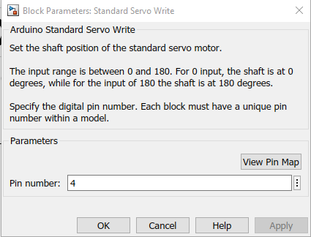

If we want the servo rotate following a sinusoidal function $θ = {180}^{°}abs(sin(t))$. What vectors of output values should be put? attach a screenshot of the ‘desired shaft angle’ block and scope block. Can you observe the sinusoidal rotation?

Answer:

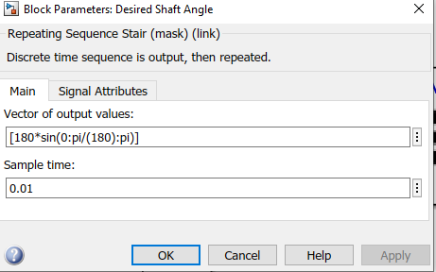

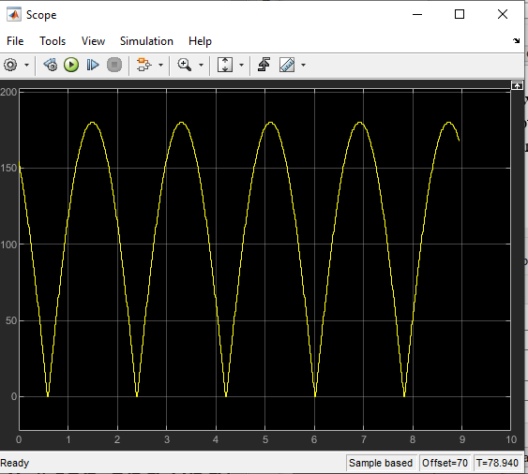

**Exercise 3: code generation**

Go to the folder path:

C:\Users\username\OneDrive\Documents\MATLAB\AtmelAVR\arduino_servocontrol_sweep

Find out C-file named ***arduino_servocontrol_sweep***

***Copy and Paste the C-code here.***

*/\**

*\* arduino_servocontrol_sweep.c*

*\**

*\* Academic License - for use in teaching, academic research, and meeting*

*\* course requirements at degree granting institutions only. Not for*

*\* government, commercial, or other organizational use.*

*\**

*\* Code generation for model "arduino_servocontrol_sweep".*

*\**

*\* Model version : 3.5*



*\* Simulink Coder version : 9.4 (R2020b) 29-Jul-2020*

*\* C source code generated on : Mon Mar 1 19:44:59 2021*

*\**

*\* Target selection: ert.tlc*

*\* Embedded hardware selection: Atmel->AVR*

*\* Code generation objectives: Unspecified*

*\* Validation result: Not run*

*\*/*

*#include "arduino_servocontrol_sweep.h"*

*#include "arduino_servocontrol_sweep_private.h"*

*/* Block states (default storage) */*

*DW_arduino_servocontrol_sweep_T arduino_servocontrol_sweep_DW;*

*/* Real-time model */*

*static RT_MODEL_arduino_servocontrol_T arduino_servocontrol_sweep_M_;*

*RT_MODEL_arduino_servocontrol_T *const arduino_servocontrol_sweep_M =*

*&arduino_servocontrol_sweep_M_;*

*static void rate_monotonic_scheduler(void);*

*/\**

*\* Set which subrates need to run this base step (base rate always runs).*

*\* This function must be called prior to calling the model step function*

*\* in order to "remember" which rates need to run this base step. The*

*\* buffering of events allows for overlapping preemption.*

*\*/*

*void arduino_servocontrol_sweep_SetEventsForThisBaseStep(boolean_T *eventFlags)*

*{*

*/* Task runs when its counter is zero, computed via rtmStepTask macro */*

*eventFlags[1] = ((boolean_T)rtmStepTask(arduino_servocontrol_sweep_M, 1));*

*}*

*/\**

*\* This function updates active task flag for each subrate*

*\* and rate transition flags for tasks that exchange data.*

*\* The function assumes rate-monotonic multitasking scheduler.*

*\* The function must be called at model base rate so that*

*\* the generated code self-manages all its subrates and rate*

*\* transition flags.*

*\*/*

*static void rate_monotonic_scheduler(void)*

*{*

*/* Compute which subrates run during the next base time step. Subrates*

*\* are an integer multiple of the base rate counter. Therefore, the subtask*

*\* counter is reset when it reaches its limit (zero means run).*

*\*/*

*(arduino_servocontrol_sweep_M->Timing.TaskCounters.TID[1])++;*

*if ((arduino_servocontrol_sweep_M->Timing.TaskCounters.TID[1]) > 9) {/* Sample time: [0.01s, 0.0s] */*

*arduino_servocontrol_sweep_M->Timing.TaskCounters.TID[1] = 0;*

*}*

*}*

*/* Model step function for TID0 */*

*void arduino_servocontrol_sweep_step0(void) /* Sample time: [0.001s, 0.0s] */*

*{*

*{ /* Sample time: [0.001s, 0.0s] */*

*rate_monotonic_scheduler();*

*}*

*}*

*/* Model step function for TID1 */*

*void arduino_servocontrol_sweep_step1(void) /* Sample time: [0.01s, 0.0s] */*

*{*

*uint8_T rtb_FixPtSum1;*

*/* MultiPortSwitch: '<S1>/Output' incorporates:*

*\* Constant: '<S1>/Vector'*

*\* UnitDelay: '<S2>/Output'*

*\*/*

*rtb_FixPtSum1 =*

*arduino_servocontrol_sweep_P.DesiredShaftAngle_OutValues[arduino_servocontrol_sweep_DW.Output_DSTATE];*

*/* MATLABSystem: '<Root>/Standard Servo Write' incorporates:*

*\* Constant: '<S1>/Vector'*

*\* MultiPortSwitch: '<S1>/Output'*

*\*/*

*if (rtb_FixPtSum1 > 180) {*

*rtb_FixPtSum1 = 180U;*

*}*

*MW_servoWrite(0, rtb_FixPtSum1);*

*/* End of MATLABSystem: '<Root>/Standard Servo Write' */*

*/* Sum: '<S3>/FixPt Sum1' incorporates:*

*\* Constant: '<S3>/FixPt Constant'*

*\* UnitDelay: '<S2>/Output'*

*\*/*

*rtb_FixPtSum1 = (uint8_T)((uint16_T)*

*arduino_servocontrol_sweep_DW.Output_DSTATE +*

*arduino_servocontrol_sweep_P.FixPtConstant_Value);*

*/* Switch: '<S4>/FixPt Switch' */*

*if (rtb_FixPtSum1 > arduino_servocontrol_sweep_P.LimitedCounter_uplimit) {*

*/* Update for UnitDelay: '<S2>/Output' incorporates:*

*\* Constant: '<S4>/Constant'*

*\*/*

*arduino_servocontrol_sweep_DW.Output_DSTATE =*

*arduino_servocontrol_sweep_P.Constant_Value;*

*} else {*

*/* Update for UnitDelay: '<S2>/Output' */*

*arduino_servocontrol_sweep_DW.Output_DSTATE = rtb_FixPtSum1;*

*}*

*/* End of Switch: '<S4>/FixPt Switch' */*

*}*

*/* Model initialize function */*

*void arduino_servocontrol_sweep_initialize(void)*

*{*

*/* Registration code */*

*/* initialize real-time model */*

*(void) memset((void *)arduino_servocontrol_sweep_M, 0,*

*sizeof(RT_MODEL_arduino_servocontrol_T));*

*/* states (dwork) */*

*(void) memset((void *)&arduino_servocontrol_sweep_DW, 0,*

*sizeof(DW_arduino_servocontrol_sweep_T));*

*/* Start for MATLABSystem: '<Root>/Standard Servo Write' */*

*MW_servoAttach(0, 4);*

*/* InitializeConditions for UnitDelay: '<S2>/Output' */*

*arduino_servocontrol_sweep_DW.Output_DSTATE =*

*arduino_servocontrol_sweep_P.Output_InitialCondition;*

*}*

*/* Model terminate function */*

*void arduino_servocontrol_sweep_terminate(void)*

*{*

*/* (no terminate code required) */*

*}*